Key Issue 1: Where Are States Distributed?
Pages 260-267

***Always keep your key term packet out whenever you take notes from Rubenstein. As the terms come up in the text, think through the significance of the term.
- Define state:

- Define sovereignty:

- List the 6 largest states in order.

- How many microstates are recognized? What do many have in common? List 6 that you can find on a map, and state where they are. (If you can only come up with 3 on your own, you’ll have to look up three more!)

- When was the United Nations established? By whom?

- Identify the reason for which membership in the UN grew significantly in each of the following periods.

1955
1960
1990s
- Who are the five permanent members of the Security Council?

- Identify some of the problems the UN faces as it attempts to operate and influence world affairs.

- There is some disagreement about how many states there actually are in the world because of regions which may, or may not, actually be states. Complete the chart to demonstrate three cases.

Korea (North & South) | People’s Democratic Republic of China (China) and/or Republic of China (Taiwan) | Western Sahara or Sahrawi Republic
One state if you agree that… | One state if you agree that… | One state if you agree that…
Two states if you agree that… | Two states if you agree that… | No state if you agree that…

- Complete the graphic organizers on the topics indicated below as they related to the history of the concept of political states and their developments.
Ancient States
Medieval States

- Define nation-state:

- Define self-determination:

Key Issue 2: Why Are Nation-States Difficult to Create?
Pages 268-275
- What is a multiethnic state? Give an example.

- What is a multinational state? Describe in detail how the United Kingdom is an example.

- Why is Denmark a fairly good example of a nation-state?

- Two regions of Denmark prevent the country from being a “perfect” nation-state. List and describe them in the chart below

Denmark’s Non-Danish Regions
Region: | Region:
Description: | Description:

- Shade and label Denmark and her territories on this map of the North Atlantic region.

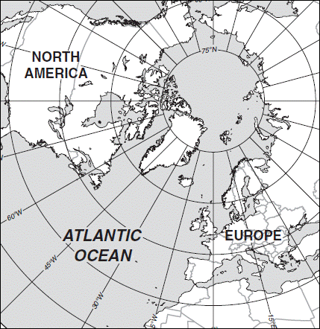
- How did Communists suppress the issues of ethnicity and nationalism? (Give several examples)

- With the fall of Communist governments in the 1990s, what kinds of problems have arisen in what places? Why?

- When the Soviet Union dissolved into 15 countries in the 1990s, the new countries were based on ethnicities. Other than Russia, they can be divided into 4 groups based on their location. Complete the chart below to indicate the countries in each group. NOTE: Be sure to look at the map on pg. 270 to familiarize yourself with the location of these countries.

Baltic Region
(3 states)
Eastern Europe
(3 states)
Central Asia
(5 states)
Caucusus
(3 states)

- Note the major religion and language of each of the Baltic States.

- The ethnic divisions among the Eastern European states are blurred for what reasons?

- What did the majority of Moldovans want when they gained independence? Who opposed this?

- Have there been ethnic problems in Central Asia? If so, where? If not, why not?

- How many different nationalities (ethnicities) are found in the country of Russia?

- Why are independence movements flourishing among these groups?

- Russia has resisted the independence movement in Chechnya for what two reasons?

- In the Caucusus region, there have been many problems with the new nations and ethnicities. Summarize the main problems and note specifics of regions and peoples for each.

Azeris (Azerbaijan)
Armenians (Armenia)
Georgians (Georgia)

- Using Figure 8-22, what’s the main problem with the Caucusus region?

- By definition, what is a colony?

- Define colonialism:

- Summarize three reasons Europeans sought colonies.

- Which country had the largest empire? Second largest?

- Use the chart below to contrast the basic colonial policies of these two countries.

Colonial Practices of… | Colonial Practices of…

- List the largest remaining colonies in the world and who possesses each.

Key Issue 3: Why Do Boundaries Cause Problems?
Pages 276-285

- Define boundary:

- Define physical boundary:

- Define cultural boundary:

- Complete the chart below to describe the advantages of each type of physical boundary.

Deserts | Mountains | Water

- What are three types of cultural boundaries that have often been used? Give an example of each type of cultural boundary and describe.

Case Study: Cyprus
- Bullet in the most significant facts regarding the boundary and ethnic situation in Cyprus. Annotate the map as appropriate.

Shapes of States
- Complete the chart based on your reading. The text gives examples of African countries that you should provide (map pg. 280).

Shapes |  | Examples
Compact | Greatest advantage…
Elongated | Biggest problem…
Prorupted | Reason for prorupting the shape of a state…
Perforated | How is the perforator state dependent on the “perforatee”?
Fragmented | Different kinds…

- Define landlocked state:

- Where are most of the world’s landlocked states?

- Why there?

- What problems do landlocked states have?

- Shade and label all 15 of Africa’s landlocked states. (Use Figure 8-33 to help)

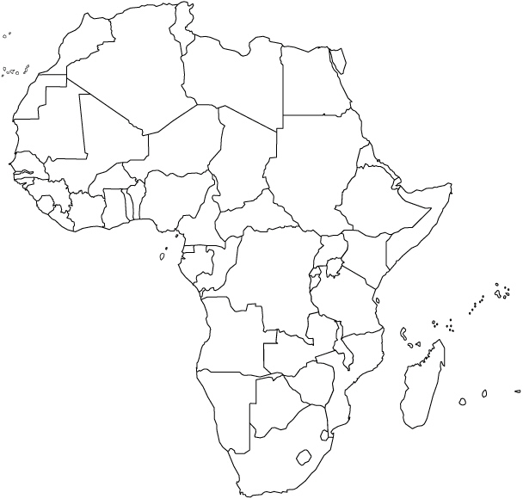

- Define democracy:
- Define autocracy:

- What are the three areas democracies and autocracies differ?

- Why has the world become more democratic?

- Explain the Arab Spring.

- Define unitary state:

- Define federal state:

- Regarding unitary states, what are the three characteristics that tend to favor it for a country?

- Where are unitary states most common?

- Multinational states often adopt unitary systems for what reason? Also, describe an example where this has occurred.

- Why is the federal state system more effective for larger states?

- List good examples of federal states that fulfill these conditions rather well.

- Why has tiny Belgium adopted a federal system?

- Why has enormous China adopted a unitary system?

- Describe the internal political organization of France in the box below.

France: Internal Political Organization
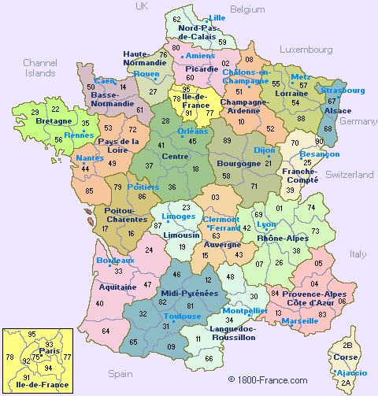

- Why are boundaries of legislative districts occasionally redrawn? How often is this done in the U.S.?

- How is this type of boundary redrawing different in the U.S. than in Europe?

- What is gerrymandering?

- What are the three types of gerrymandering? Explain them.

- How is gerrymandering combined with ethnicity for political use?

Key Issue 4: Why Do States Cooperate and Compete with Each Other?
Pages 286-295

- Why is the idea of two superpowers a relatively new one?

- Define balance of power:

- Describe the purpose of NATO.

- Describe the purpose of the former “Warsaw Pact” countries.

- When was the European Union (EU) formed?

- By what states?

- For what purpose?

- What are some important changes in recent years?

- Briefly explain the Eurozone Crisis.

- Complete the chart on notable non-military regional organizations.

Regional Organization | Members | Purpose
OSCE (Organization on Security and Cooperation in Europe)

OAS (Organization of American States)
AU (African Union)
The Commonwealth
- By definition, what is terrorism?

- List typical methods/acts of terrorists.

- Why is terrorism different from other acts of political violence?

- List some places in which Americans were attacked by terrorists in the late 20th century and early 21st century.

- Identify each of the following terms as they relate to the terrorist organization known as Al-Qaeda.
  - Osama bin-Laden:

  - Afghanistan:

  - Yemen & Somalia:

  - “the base”:

  - fatwa:

- In what ways does Al-Qaeda, its religious and political views, and its methods pose a challenge to Muslims?

- In what ways does Al-Qaeda, its religious and political views, and its methods pose a challenge to Americans?

- List three ways in which states (particularly in the Middle East in recent decades) have given support to terrorists.

- Note in which of the above ways each of the following states has supported terrorism and then briefly describe it.

State | Type of Support | Brief Summary of Issues
Afghanistan
Pakistan
Iraq
Iran
Libya

